Compensation
SuccessFactors Exclusion table : This exclusion table is built in Peoplesoft
Not everyone in the organization with be eligible for may be a
Merit increase or Bonus or vice versa
OR,
May be eligible of Bonus but not Merit Increase
May be eligible for Merit increase but not for a Bonus
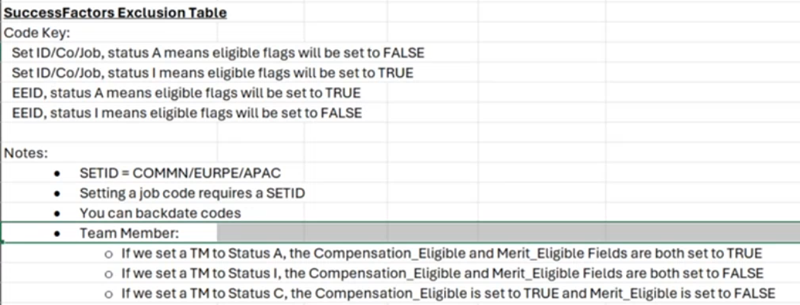

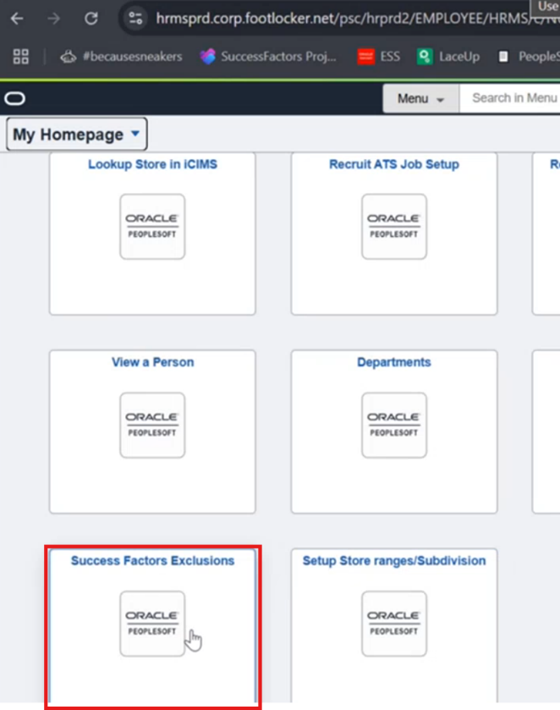

Types of Exclusion:
-Job Code exclusions-
- Set Id Exclusions -
- EE Id or for Team members -

